Task-1
Draw and label diagrams of star, bus, and mesh network topologies on paper or using any drawing tool. For each, write one real-world app or service (like WhatsApp, Flipkart, or IPL streaming) that could use that topology and explain why in 1-2 lines.
Ans:
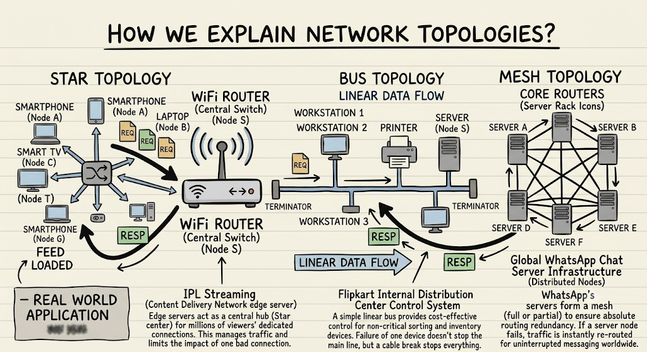

Task-2
Create a comparison table listing at least four pros and four cons for each of these topologies: star, bus, ring, mesh. Include a column for 'Best Use Case' and give an example from apps you use (e.g., Instagram, Zomato, Paytm).
Ans:
Topology | Pros | Cons | Best Use Case | Real-World App / Example
Star | 1. Easy to install and add new devices without disrupting the network.  2. Single device failure does not affect others.  3. Centralized management makes monitoring and troubleshooting simple.  4. High performance since each device has a dedicated link to the central switch. | 1. Entire network fails if the central hub/switch crashes (single point of failure).  2. Higher cable requirement compared to bus topology.  3. Hub/switch hardware adds to initial setup costs.  4. Performance degrades if the central hub reaches capacity limits. | Client-server communication models and home/office local area networks. | IPL Streaming / JioCinema: Millions of smartphones connect individually as leaf nodes directly to a central edge server (CDN hub) to fetch the video stream.
Bus | 1. Minimal cabling needed, keeping material costs low.  2. Simple architecture; easy to connect a few devices in a straight line.  3. Cost-effective for temporary or small setups.  4. Easy to understand and implement without active switches. | 1. A break or damage in the main backbone cable halts the entire network.  2. High packet collision risk as traffic loads increase.  3. Terminators are strictly required at both ends to prevent signal reflection.  4. Difficult to isolate and troubleshoot individual node faults. | Small, low-traffic environments and linear assembly lines or non-critical store terminals. | Flipkart Warehouse Conveyor Belt: Linear barcode scanners and weight check terminals along a sorting line communicating non-critical status updates to a line controller.
Ring | 1. Orderly data transmission via tokens eliminates data collisions.  2. Performs better than bus topology under heavy workloads.  3. Requires less cabling than mesh topology.  4. Equal network access privileges for all connected devices. | 1. A break in a unidirectional ring takes down the entire communication loop.  2. Adding or removing a node briefly disrupts the entire ring.  3. Transmission delay increases proportionally with the number of nodes.  4. Troubleshooting is complex because every node must pass the token. | High-speed fiber-optic campus backbones and metropolitan industrial automation (often using dual rings for redundancy). | Paytm Payment Core Banking Settlement Ring: Bank gateway nodes passing transaction settlement batches sequentially in a token-passing loop for verified reconciliation.
Mesh | 1. Extreme fault tolerance—traffic automatically reroutes if one path fails.  2. No single point of failure (in full mesh).  3. Simultaneous data transfers provide high bandwidth and throughput.  4. Dedicated point-to-point links offer superior privacy and security. | 1. Extremely expensive due to massive cabling and port requirements.  2. High installation and configuration complexity.  3. High hardware maintenance overhead on multiple network interfaces.  4. Consumes significant power and rack space. | Mission-critical networks, core Internet routing, and distributed cloud databases. | Instagram / Zomato Cloud Infrastructure: Distributed data centers and edge servers interconnected via mesh routing so user requests bypass failed lines instantly without app downtime.

Task-3
Imagine you are designing a new multiplayer mobile game like PUBG or Free Fire. Choose a suitable network topology for the game servers and justify your choice in 3-4 lines, mentioning how it would impact speed, reliability, and cost.
Ans:
Topology Choice: Hybrid Topology (Star at Client-Level + Mesh at Server-Core)

- Architecture: Up to 100 mobile players connect directly as leaf nodes to a central regional match server in a Star topology, while multiple regional data centers and database clusters interconnect using a Mesh topology.
- Impact on Speed: The direct Star link to an authoritative game server minimizes packet round-trip time (low ping) and prevents peer-to-peer lag imbalances.
- Impact on Reliability: The central server prevents cheating/desync by acting as the single source of game truth, while the backend server mesh provides automated failover so match stats and logins never go offline.

- Impact on Cost: Maintaining high-capacity central compute and redundant cross-datacenter mesh links involves high infrastructure costs, but it is necessary to handle massive concurrency without crashes.
Task-4
Given this scenario: A small Flipkart-style warehouse wants to connect 8 computers for order processing and inventory updates. Recommend a network topology, sketch a quick diagram, and explain your reasoning in 2-3 lines.<br><br><em><strong>Hint:</strong> Consider factors like cost, ease of troubleshooting, and future expansion.</em>
Ans:
[ PC 1 (Order Entry) ]
|
[ PC 8 ] | [ PC 2 ]
\ | /
\ | /
[ PC 7 ]-----[ 8-Port Switch ]-----[ PC 3 ]
/ (Central Hub) \
/ | \
[ PC 6 ] | [ PC 4 ]
|
Reasoning:
- Reliability & Troubleshooting: If one workstation's cable gets damaged or unplugged on the busy warehouse floor, only that single PC disconnects while the remaining 7 continue uninterrupted order processing.
- Cost & Scalability: Standard 8- or 16-port Gigabit switches and Cat6 cables are very inexpensive, and adding new workstations as the warehouse expands simply requires plugging a new cable into an open port on the central switch.

